
DEPARTMENT OF SOFTWARE ENGINEERING

"PROJECT 4"
Secure Multi-Tier Network Architecture

SUBMITTED TO:
Sir Waqas Saleem

COURSE TITLE:
Cloud Computing

SUBMITTED BY:
Maham Saleem(2023-BSE-033)
Ainun-Noor (2023-BSE-003)
Kainat Shakeel (2023-BSE-029)

1. Executive Summary
This project presents the design and implementation of a secure multi-tier network architecture on Amazon Web Services (AWS) using Terraform and Ansible, strictly within the tools and concepts covered in the Cloud Computing course. The objective is to demonstrate how a production-style cloud environment can be securely designed, provisioned, configured, and verified using Infrastructure as Code (IaC) and configuration management.
The implemented solution follows a three-tier architecture consisting of a Web Tier, Application Tier, and Management Tier. Public access is limited to the web tier only, while the application tier remains private with no direct exposure to the internet. A bastion host is deployed in the management subnet and serves as the only entry point for administrative SSH access, reducing the attack surface.
Terraform provisions the VPC, subnets, route tables, Internet Gateway, Security Groups, and EC2 instances using a modular structure and environment-specific variable files for dev, staging, and production. Ansible automates server hardening (non-root admin user, key-only SSH, root login disabled, secure file permissions), deploys a simple application in the private tier, configures Nginx reverse proxy on the web tier, and collects logs as security evidence in the repository under docs/logs/.
Finally, the project includes security verification tests and a compliance checklist. Evidence is captured through screenshots and collected log files to demonstrate segmentation, least privilege access, bastion host SSH flow, and secure SSH configuration.

2. Architecture Design

2.1 Network Architecture Overview
The infrastructure is deployed inside a single AWS Virtual Private Cloud (VPC) and segmented into three clearly defined tiers:
Web Tier (Public Subnets): Hosts Nginx reverse proxy servers that accept HTTP traffic from external clients.
Application Tier (Private Subnets): Hosts backend application servers listening on port 8080. These instances have no public IP addresses.
Management Tier (Management Subnet): Hosts a bastion (jump) server that acts as the only SSH entry point to the environment.
Traffic Flow Summary:
• External Clients -> Web Tier (HTTP 80)
• Web Tier -> Application Tier (HTTP 8080)
• Admin IP -> Bastion Host (SSH 22)
• Bastion Host -> Web/App Servers (SSH 22)

2.2 Security Architecture
Security is enforced using Security Groups only following the least privilege principle. All tiers are isolated in dedicated subnets. Public inbound access is restricted to HTTP (port 80) on the web tier. SSH access to web and app servers is not allowed from the internet; it is permitted only from the bastion host. Security Group-to-Security Group references are used to enforce strictly controlled traffic between tiers.

3. Terraform Implementation
Terraform is used to provision all required AWS resources. The infrastructure is organized using reusable modules under terraform/modules/ (network, security, compute) and wired together from the root terraform/main.tf. Environment-specific configuration is provided using tfvars files for dev, staging, and production.

3.1 Network Module
The network module provisions the VPC, subnets for each tier, Internet Gateway, and route tables. Public subnets host the web tier and are routed to the Internet Gateway. Private subnets host the application tier and do not require a default internet route for this project (documented limitation). All subnets are tagged by tier (Tier=web, Tier=app, Tier=management).

3.2 Security Module
The security module creates least-privilege Security Groups for the web, app, and bastion tiers. Inbound and outbound rules are implemented using Security Group references to ensure only required traffic is allowed.

3.3 Compute Module
The compute module provisions EC2 instances for the web tier, application tier, and bastion host. Web instances are deployed in public subnets with Web SG. App instances are deployed in private subnets with App SG and have no public IPs. The bastion host is deployed in the management subnet with Bastion SG. Instances are tagged with Project, Environment, Tier, Role, and Name.

3.4 Root Terraform Configuration & Environments
At the root level, terraform/main.tf configures the AWS provider and backend and instantiates the network, security, and compute modules. Module outputs (VPC ID, subnet IDs, SG IDs) are wired into dependent modules. Helpful outputs are defined for bastion public IP, web public endpoint(s), and app private IPs to support Ansible inventory and verification.
Environment-specific tfvars files are used to configure CIDRs (admin IP, allowed HTTP), instance sizes, and instance counts for dev, staging, and production environments. A terraform.tfvars.example file is provided for safe sharing without secrets.

4. Ansible Implementation
Ansible is used to configure and secure the provisioned EC2 instances. Roles and playbooks are organized under ansible/ to support repeatable execution across environments. The implementation includes dynamic inventory (aws_ec2), server hardening, application deployment, Nginx reverse proxy configuration, and log collection for evidence.

4.1 Inventory and Global Configuration
Dynamic inventory is configured using the aws_ec2 plugin. Instances are discovered and grouped by tags (Tier=web/app/management). ansible.cfg standardizes inventory, privilege escalation (sudo), and SSH behavior to ensure consistent execution.

4.2 Server Hardening
A dedicated hardening role is applied to all servers. It creates a non-root admin user (e.g., deployer) with sudo access, installs common packages (vim, curl, git), and hardens SSH by disabling root login and password authentication (key-only SSH). It also enforces secure permissions on SSH configuration files and restarts the SSH service via handlers.

4.3 Nginx Reverse Proxy & Application Tier
The application role deploys a simple backend service listening on port 8080 in the private subnets (app tier). The Nginx reverse proxy role installs and configures Nginx on the web tier to forward incoming HTTP requests on port 80 to the app tier on port 8080. A /health endpoint is provided for basic service checks.

4.4 Log Collection
For centralized evidence collection within course scope, Ansible fetches key logs from all servers and stores them in the repository under docs/logs/. Collected evidence includes SSH authentication logs (/var/log/auth.log or /var/log/secure) and Nginx access/error logs from the web tier. This provides proof of hardening and runtime behavior without using CloudWatch/rsyslog.

5. Security Testing & Compliance Checklist

5.1 Security Testing Results
Security tests were performed to validate segmentation, least privilege Security Groups, and bastion host access flow. The following tests and expected outcomes were documented using screenshots:
• Attempt SSH to an app server directly from local machine - FAIL (expected) - no public IP and SG restriction
• SSH to bastion host from admin IP CIDR - SUCCESS
• SSH from bastion to web/app servers using private IPs - SUCCESS
• Access web tier public URL and verify Nginx forwards to app tier - SUCCESS
• Verify SSH hardening settings in sshd_config - PermitRootLogin no; PasswordAuthentication no

5.2 Security Compliance Checklist
The following checklist summarizes the implemented security controls and their verification evidence:
☐ Root SSH login disabled on all servers
☐ SSH password authentication disabled (key-only SSH)
☐ Non-root admin user (deployer) created and configured with SSH keys
☐ Application servers have no public IP addresses
☐ Web servers expose only HTTP (80) publicly
☐ SSH access to web/app servers allowed only via bastion host
☐ Nginx reverse proxy forwards requests to app tier on port 8080
☐ Evidence logs collected and stored under docs/logs/

6. Challenges & Solutions
During implementation, several common infrastructure and configuration issues were encountered. The following summarizes the main challenges and how they were resolved:
• SSH access risk after hardening: Applied changes gradually and tested SSH after each run. Ensured deployer key access before disabling password authentication.
• Nginx 502/504 errors: Verified app service was running on port 8080, checked Nginx upstream configuration, and confirmed SG allows web -> app traffic on 8080.
• Different SSH log paths across OS images: Handled both /var/log/auth.log (Ubuntu) and /var/log/secure (Amazon Linux) using variables and ignore_errors in fetch tasks.
• Dynamic inventory grouping issues: Validated instance tags (Project, Environment, Tier) and ensured aws_ec2 inventory filters matched exactly.

7. Conclusion & Future Improvements
This project successfully implemented a secure three-tier AWS network architecture using Terraform and Ansible within course scope. Network segmentation, least privilege Security Groups, bastion host access, SSH hardening, and Nginx reverse proxy were implemented and verified with evidence.
Future improvements (out of scope for this course) could include enabling HTTPS/TLS on Nginx, adding autoscaling for web/app tiers, centralized monitoring/alerting, and CI/CD pipelines for automated deployments.
Part 1: Git Repository Setup
  - Repository Structure
Step 1 — Go into your new repo
Step 2 — Create all folders
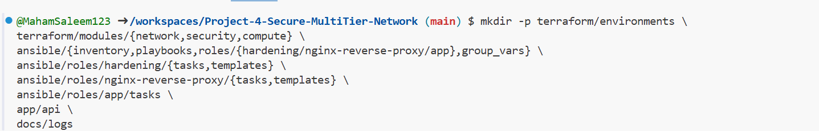

Step 3 — Create all required files
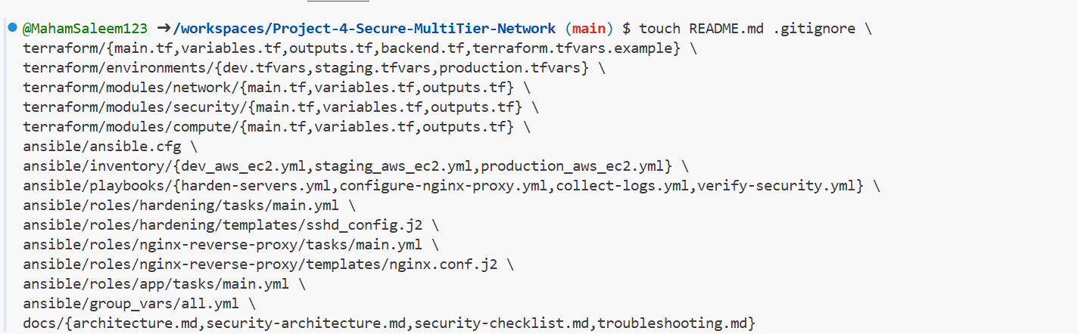
Step 4 — Verify structure (for screenshot)
project4_part1_repository_structure.png
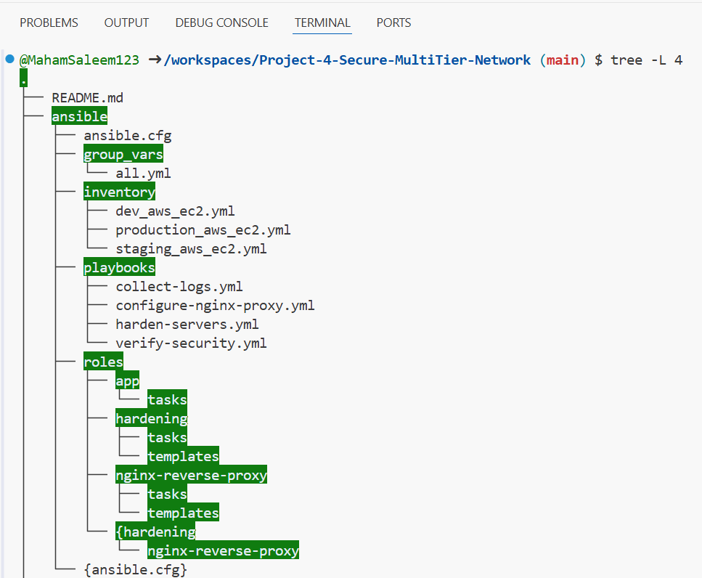
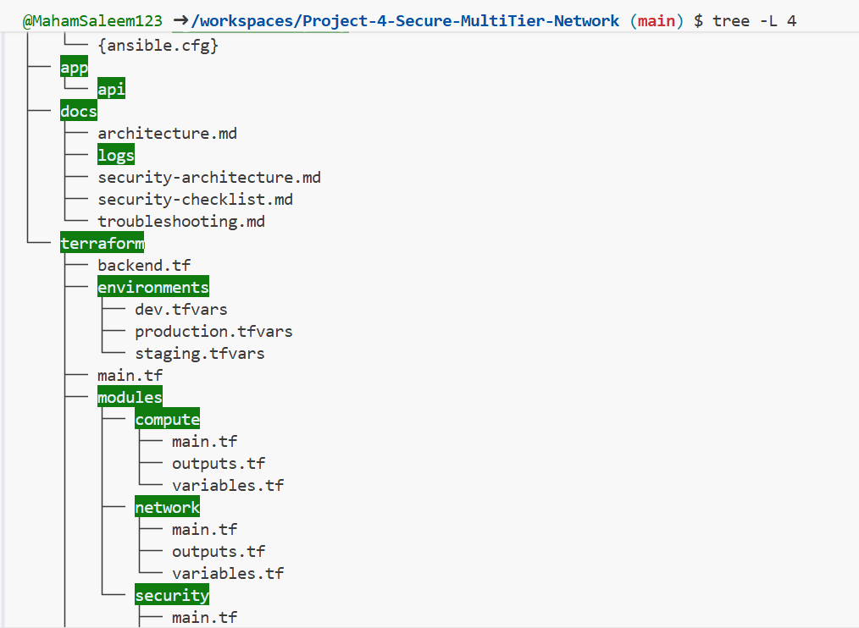
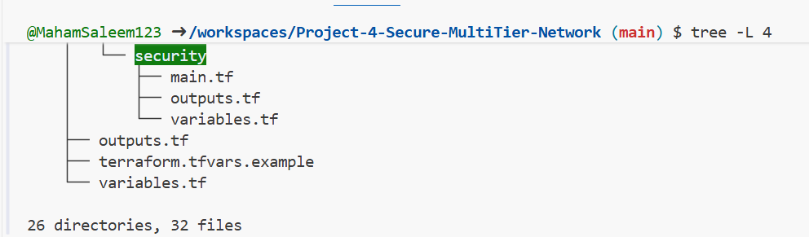

  - .gitignore Configuration

Step 5 — Open .gitignore
project4_part1_gitignore.png
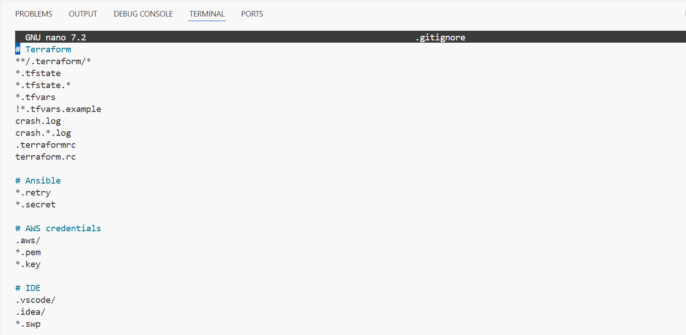
Step 6 — Check git status
project4_part1_git_status_clean.png
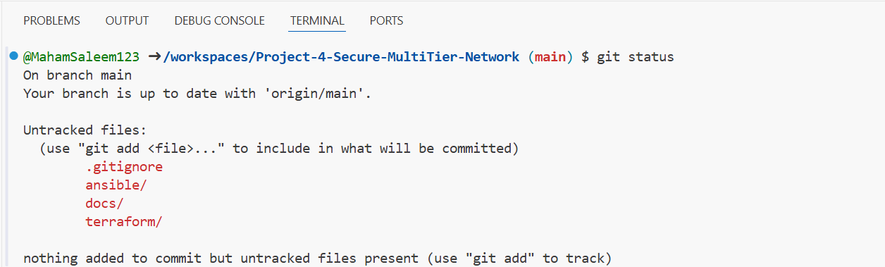

  - – Initial Commit

Step 7 — Commit
project4_part1_initial_commit.png
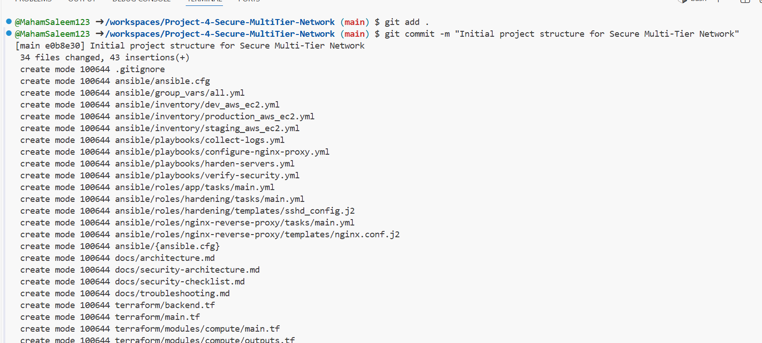
  - Git Branching Strategy

Step 8 — Create branches
Step 9 — Show branch
project4_part1_git_branches.png
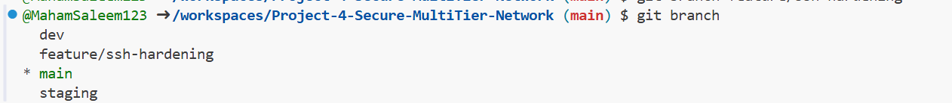

Step 10 — Document in README
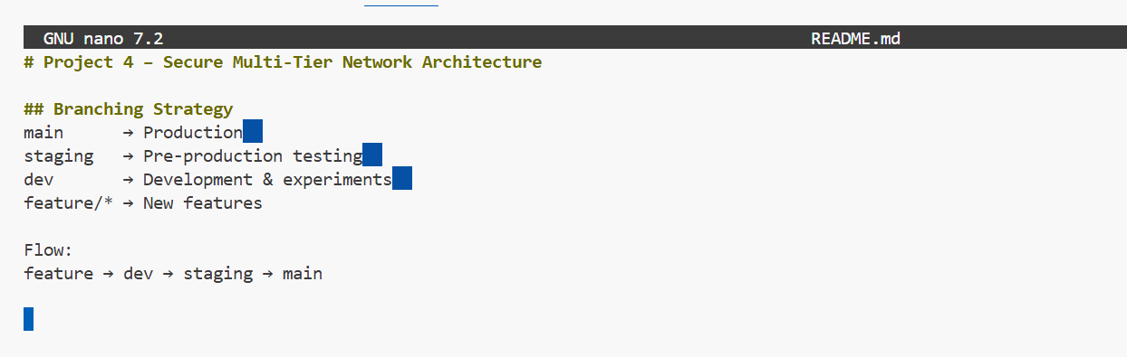
Part 2: Terraform – VPC, Security, Compute
2.1 – Network Module (VPC + Subnets)
STEP 1 — Create module folders & files
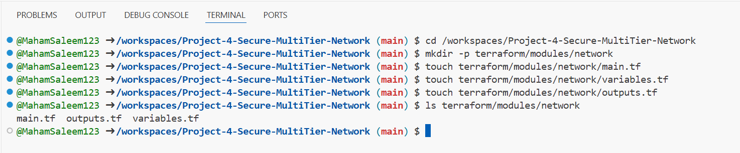
STEP 2 — variables.tf (network)
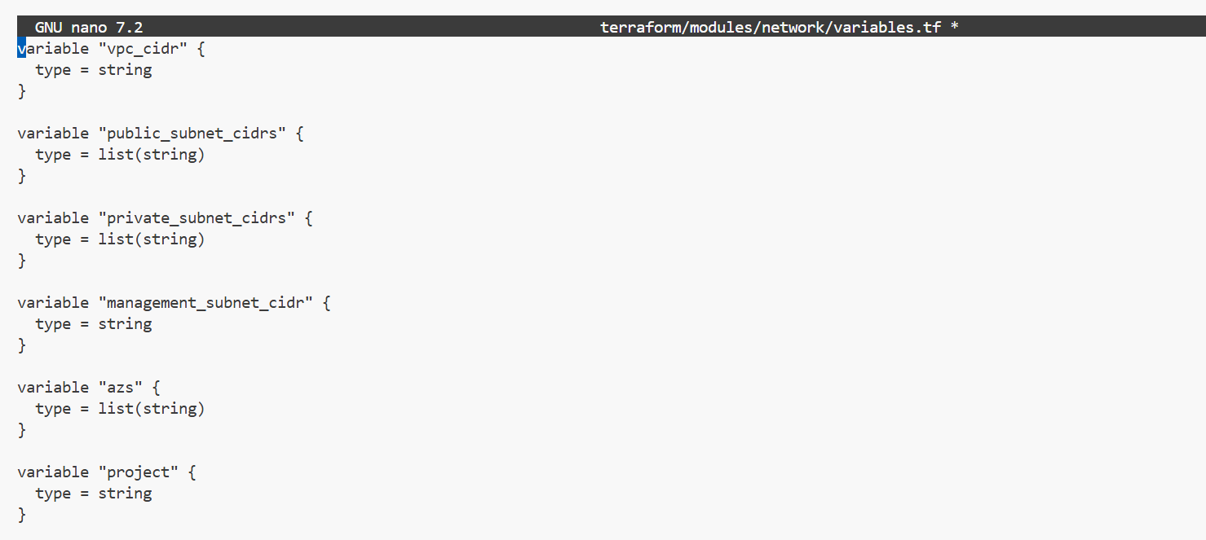

STEP 3 — main.tf (network)
project4_part2_network_main.png
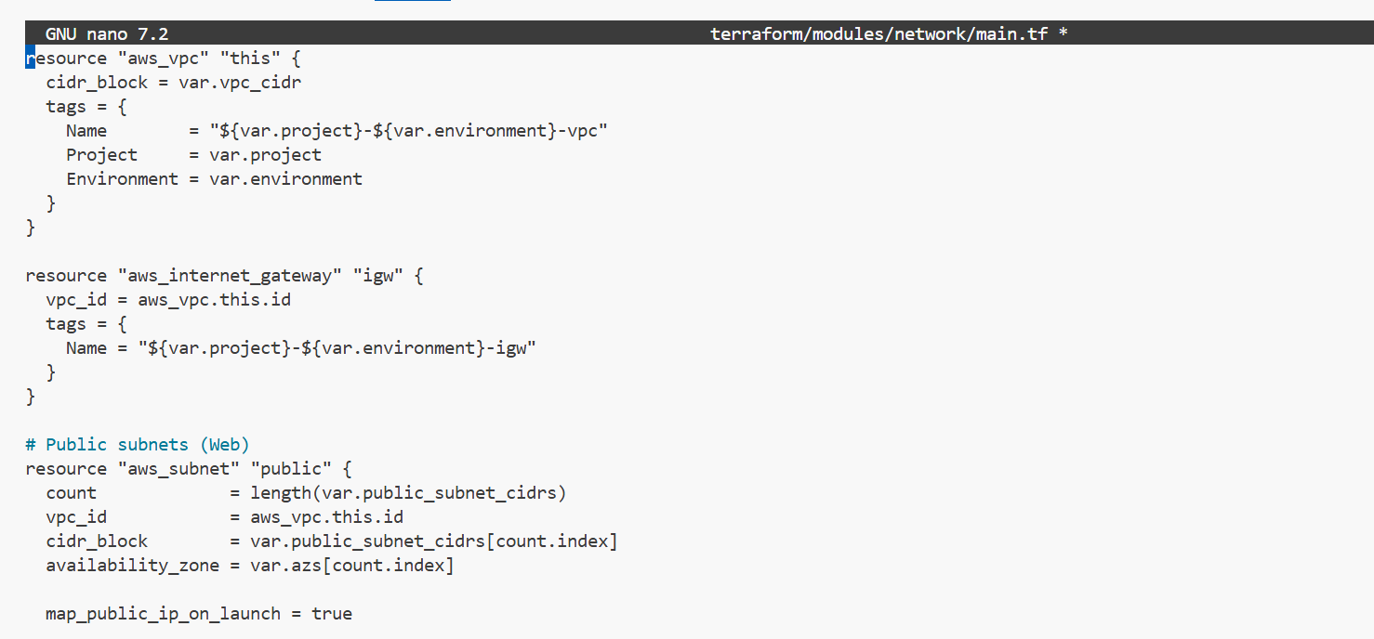
STEP 4 — outputs.tf
project4_part2_network_outputs.png
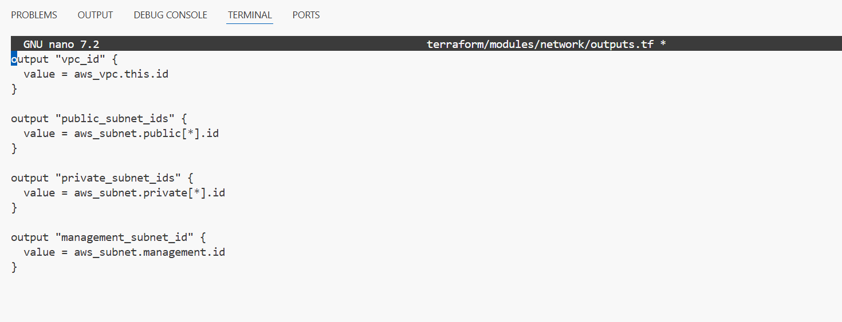
2.2 – Security Groups Module
STEP 5 — Create folder
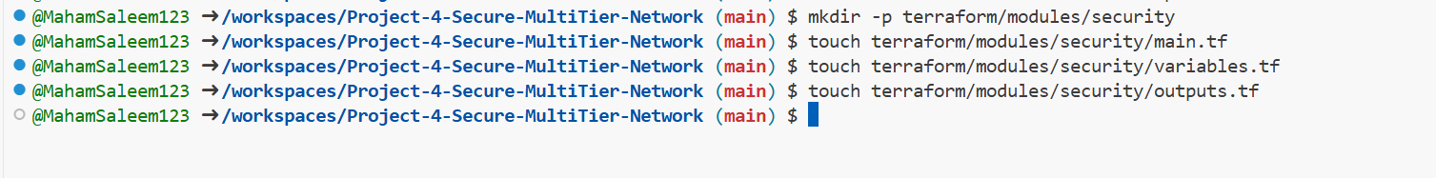
STEP 6 — variables.tf (security)
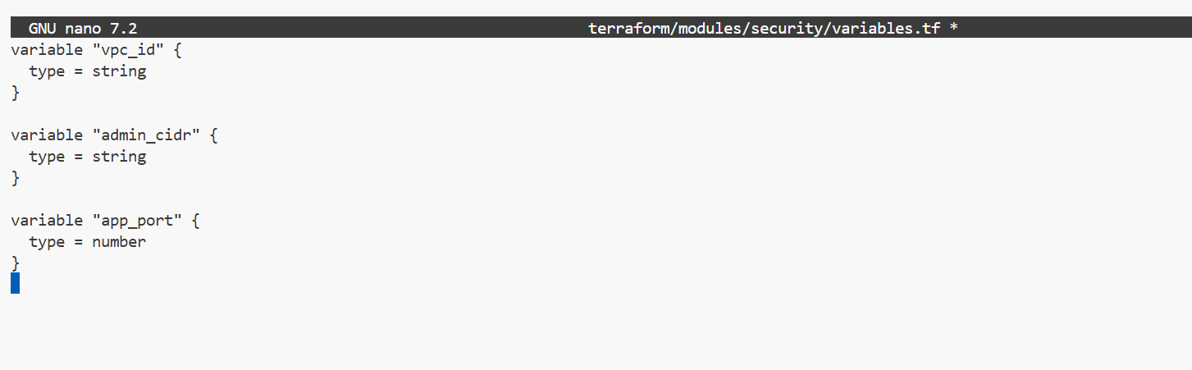
STEP 7 — main.tf (security)
project4_part2_security_main.png
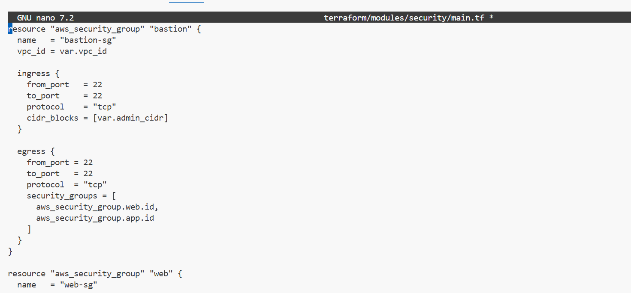
STEP 8 — outputs.tf
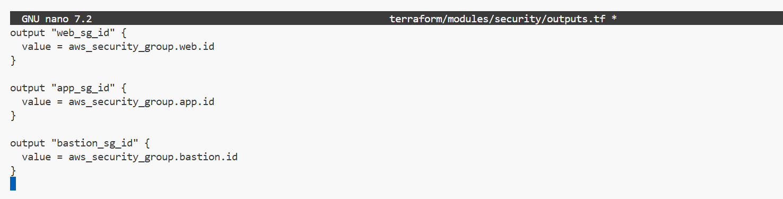

2.3 – Compute Module
STEP 9 — Create folder
STEP 10 — variables.tf (compute)
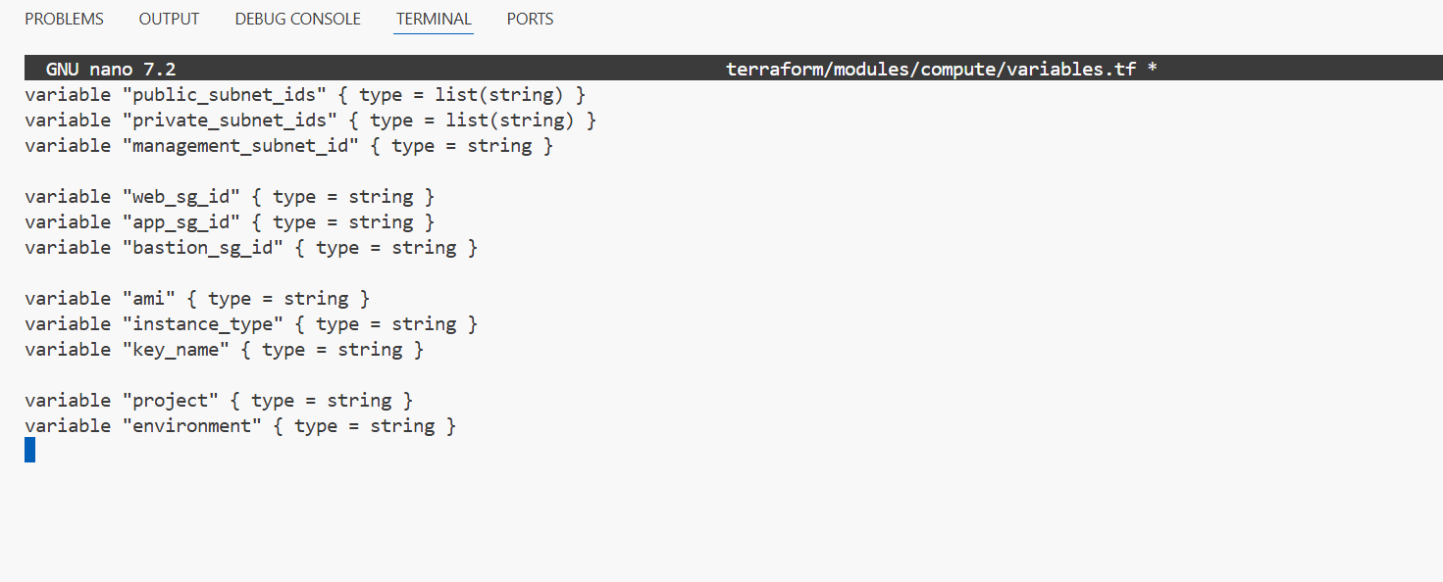
STEP 11 — main.tf (compute)
project4_part2_compute_main.png
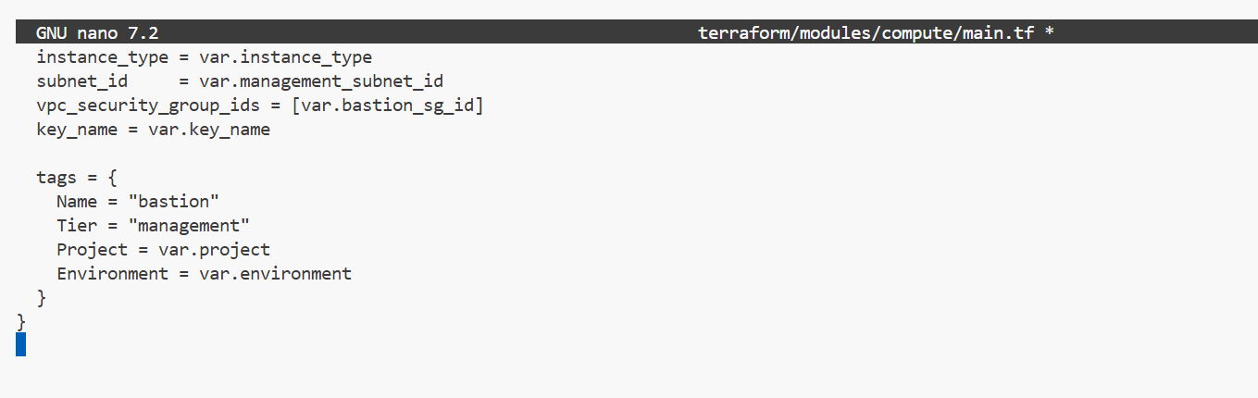

STEP 12 — outputs.tf
project4_part2_compute_outputs.png
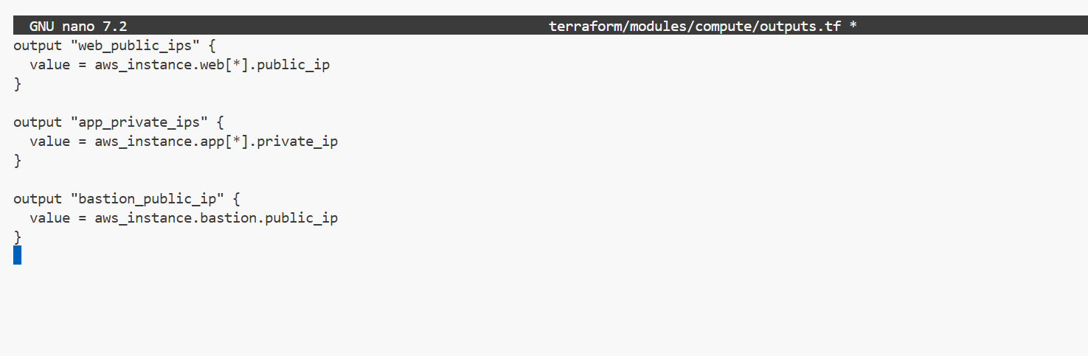
Part 3: Root Terraform & Environments
3.1 — Root Terraform Wiring
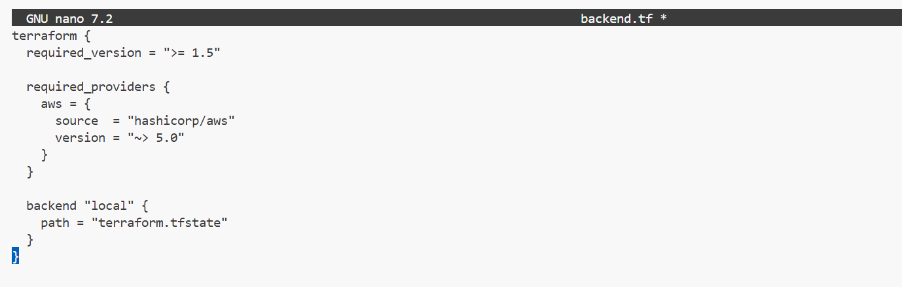
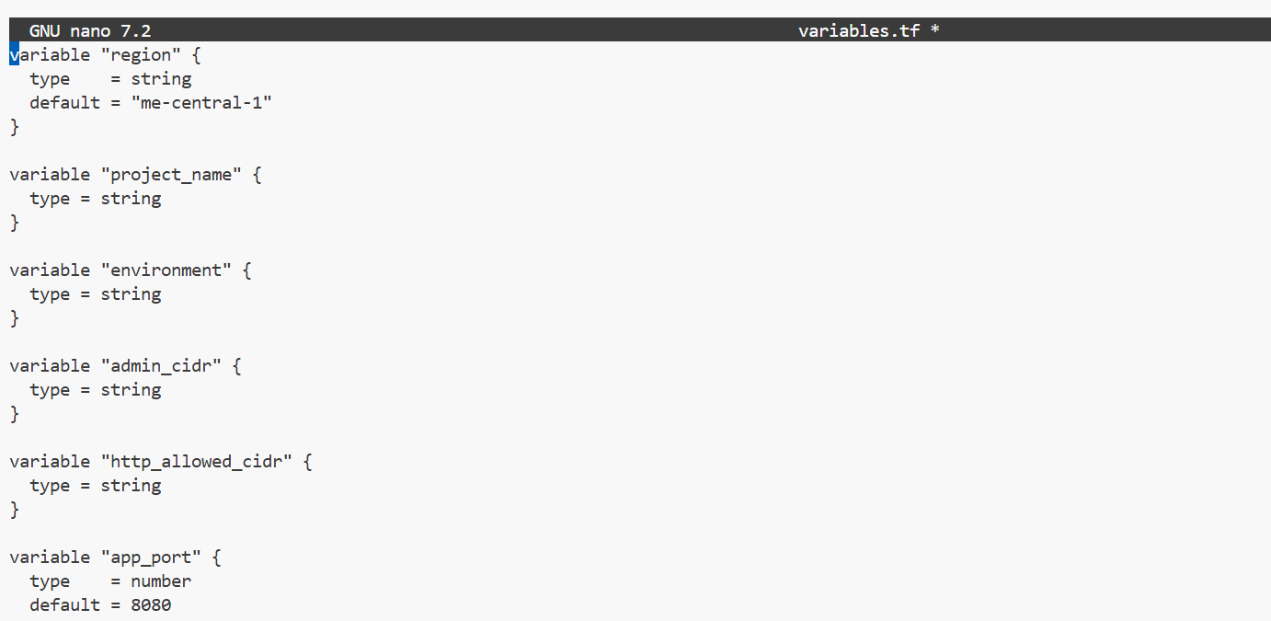

project4_part3_main_tf.png
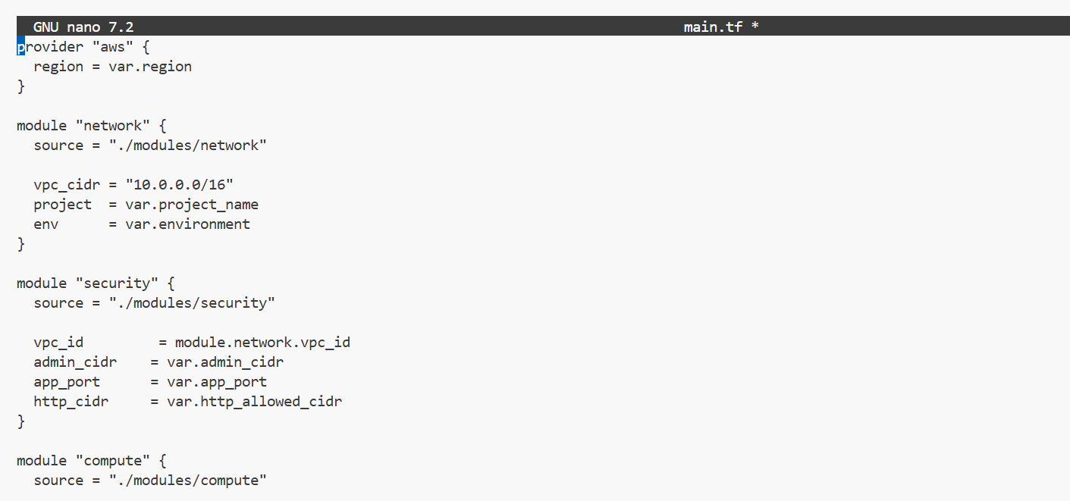

3.2 — Environment tfvars
project4_part3_dev_tfvars.png
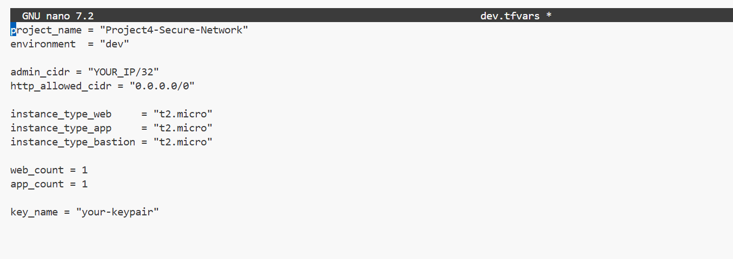
project4_part3_staging_tfvars.png
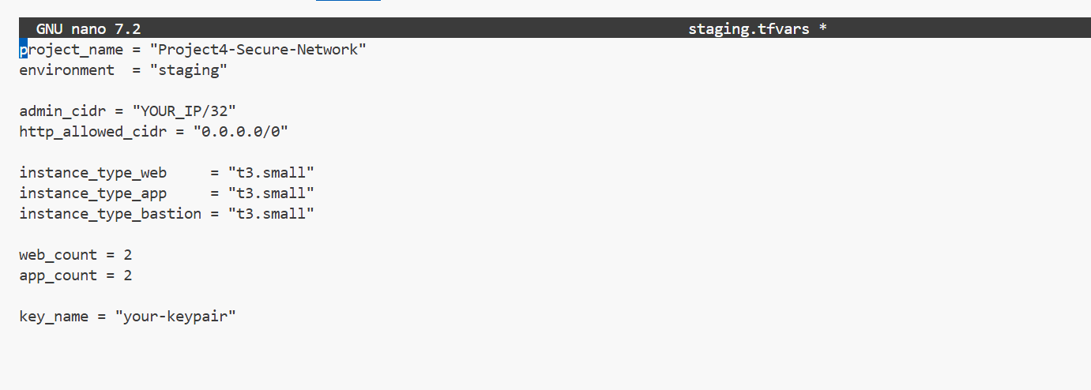
project4_part3_production_tfvars.png
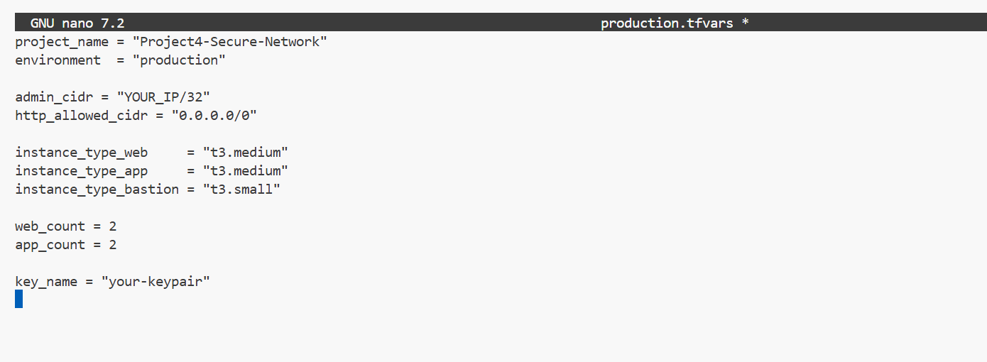
project4_part3_tfvars_example.png
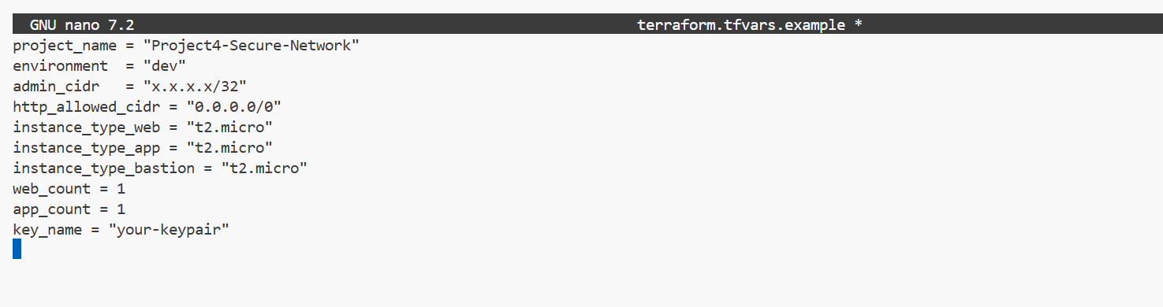
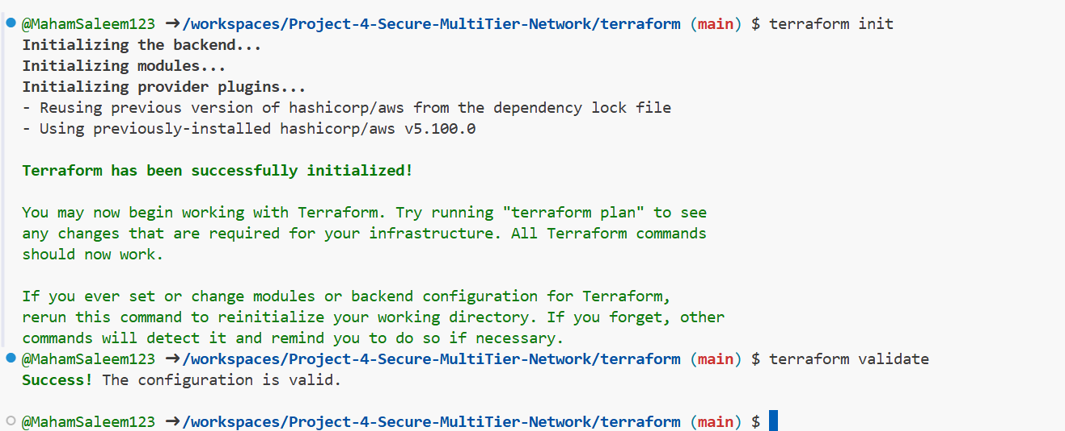
Part 4: Ansible – Hardening, Nginx Reverse Proxy, Log Collection
4.1 — Verify Inventory + Global Config
project4_part4_ansible_inventory_dev.png
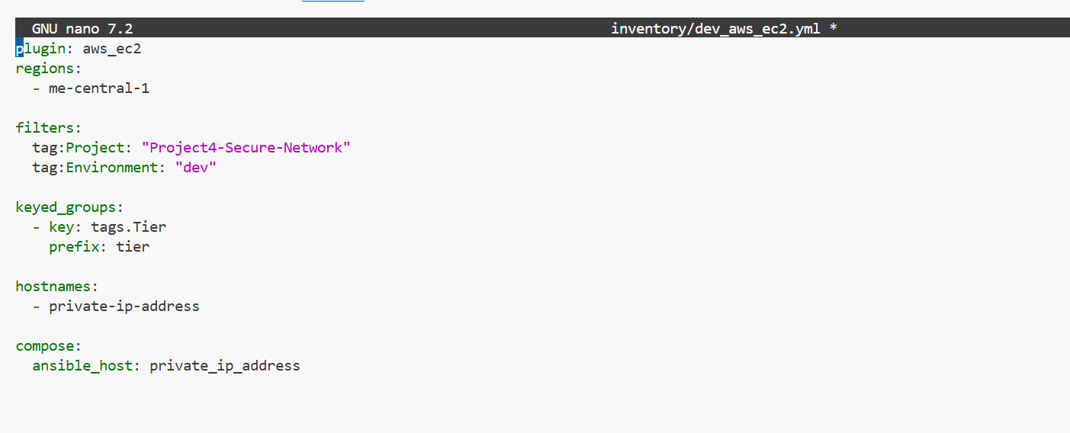
project4_part4_ansible_cfg.png
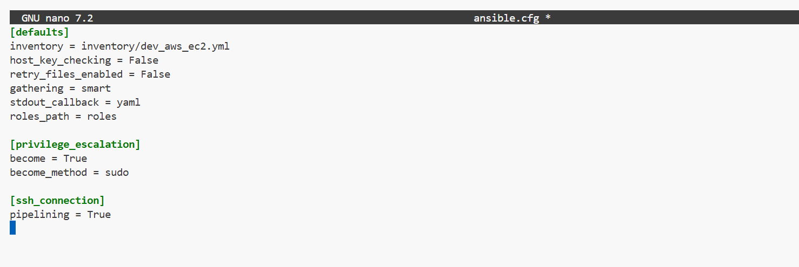
project4_part4_group_vars_all.png
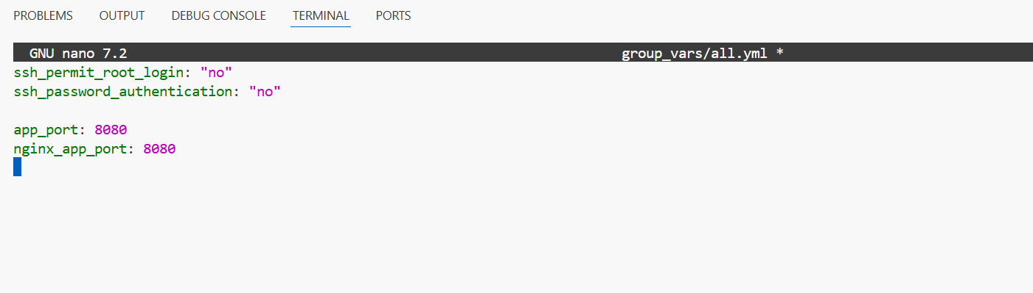
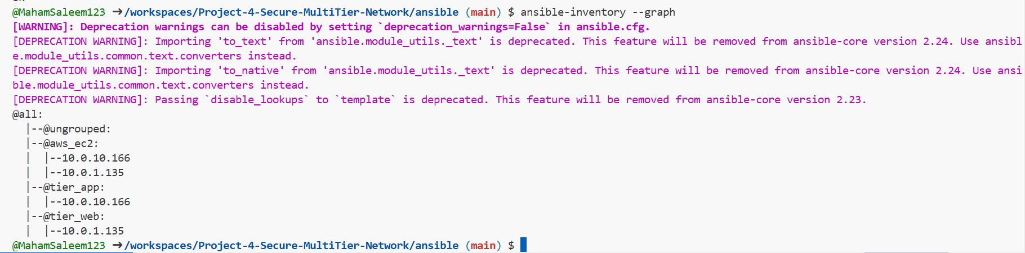

4.2 — Server Hardening
project4_part4_hardening_role_main.png
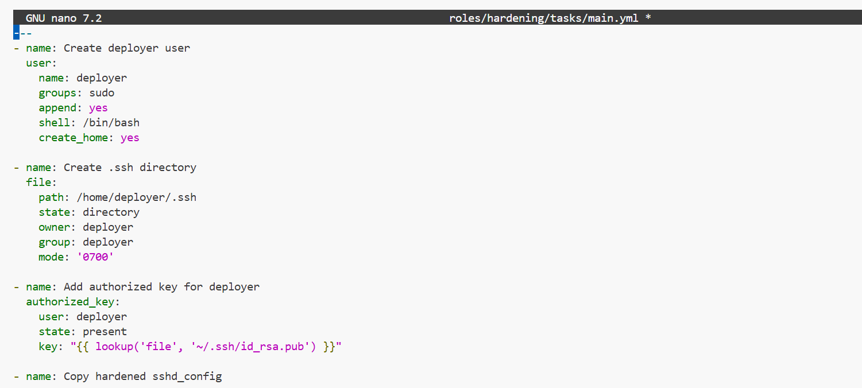
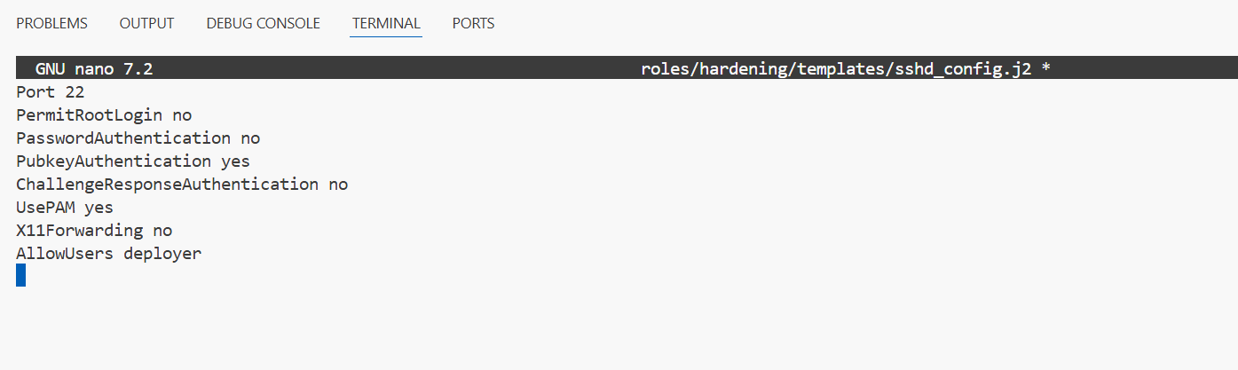
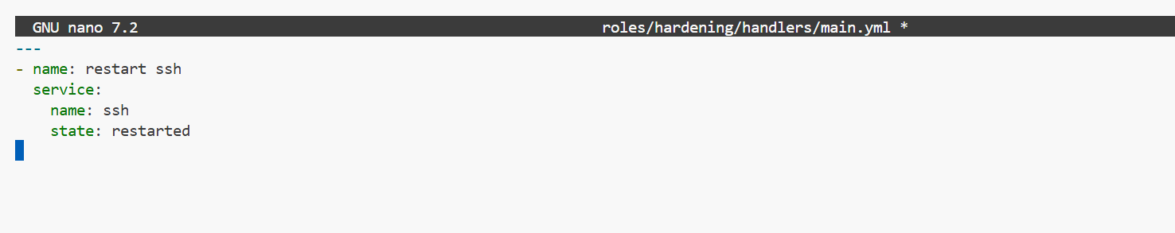
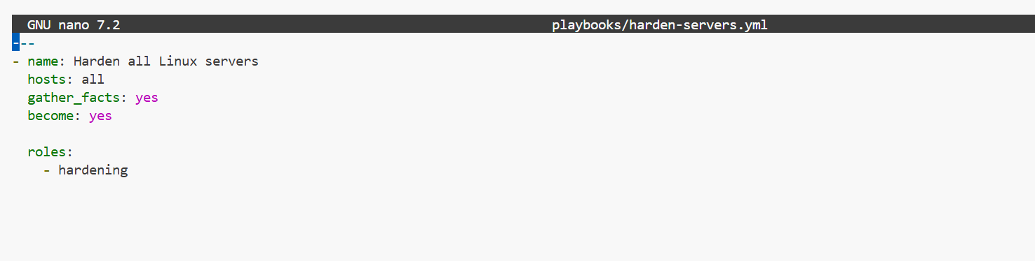
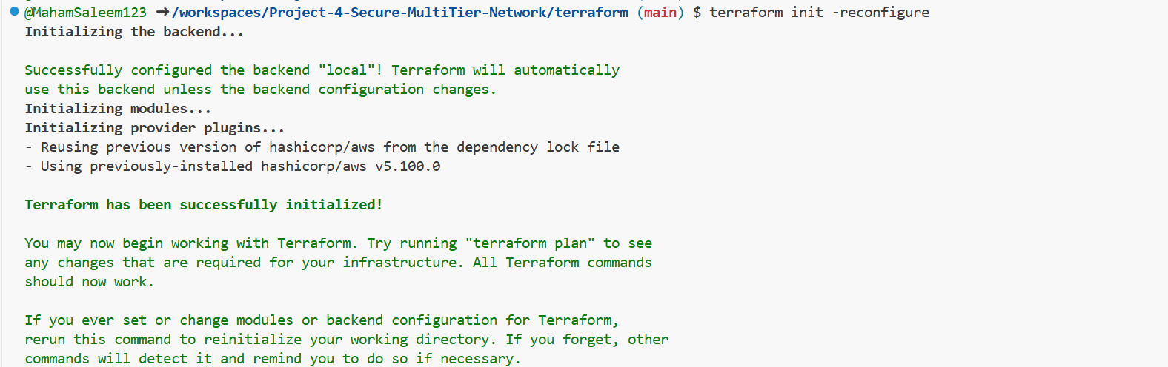
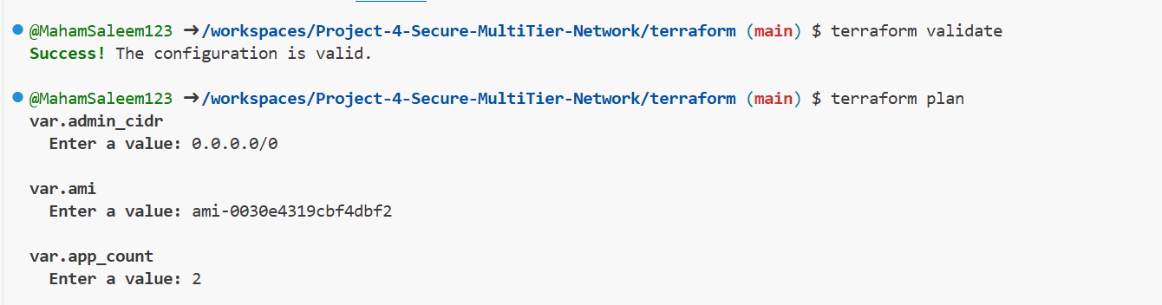
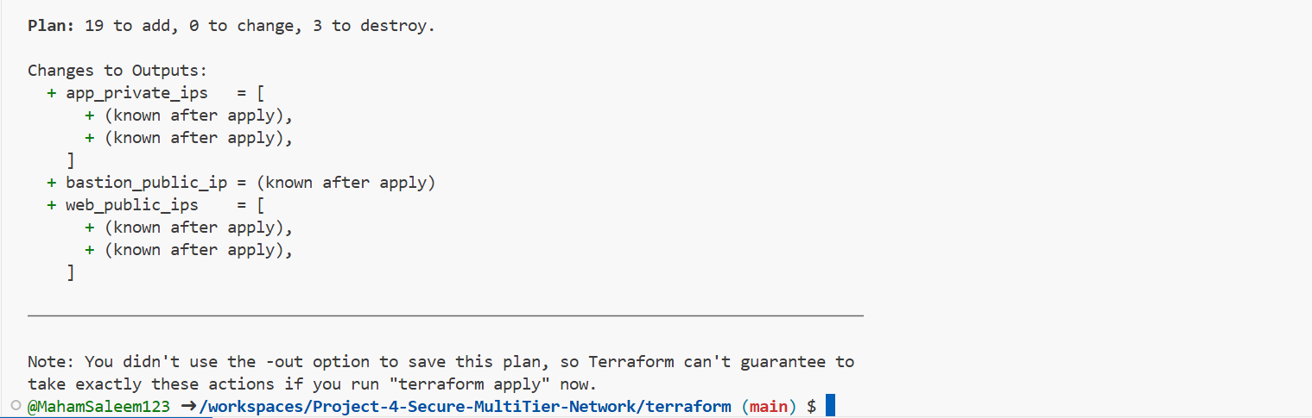

project4_part4_harden_execution.png
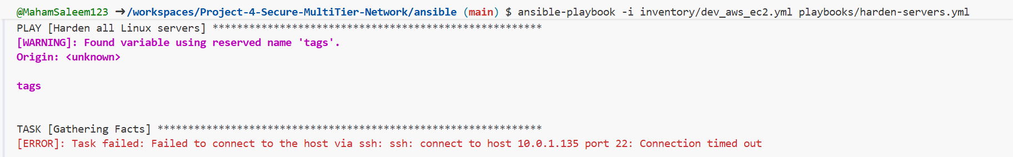
4.3 Nginx Reverse Proxy & App Tier
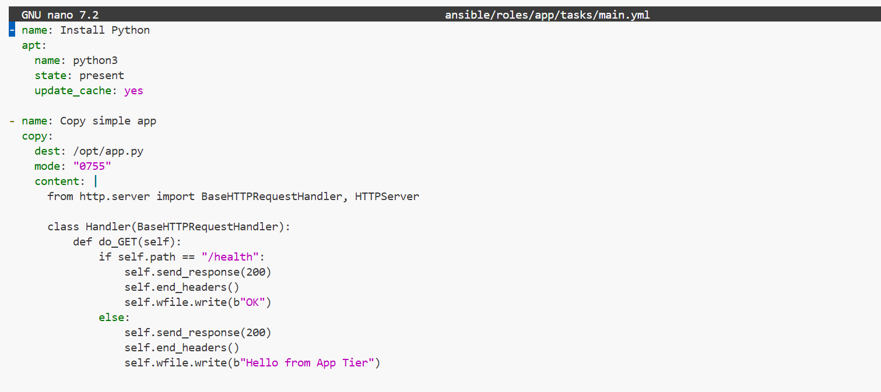
project4_part4_nginx_conf_template.png
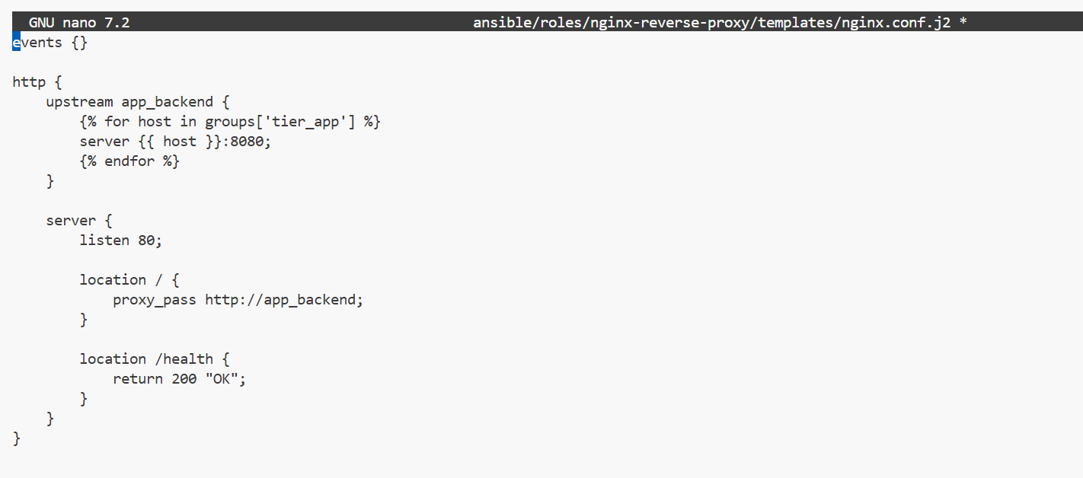
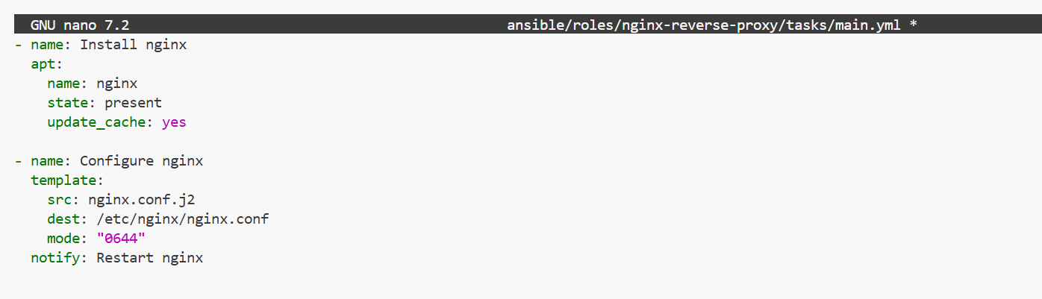
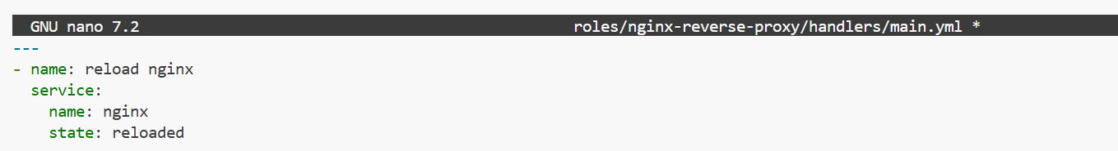
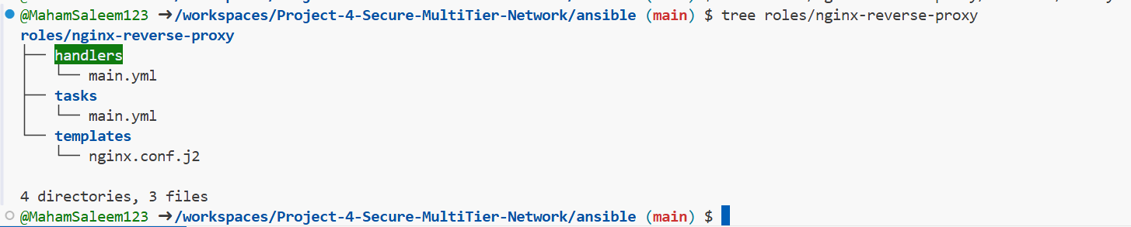
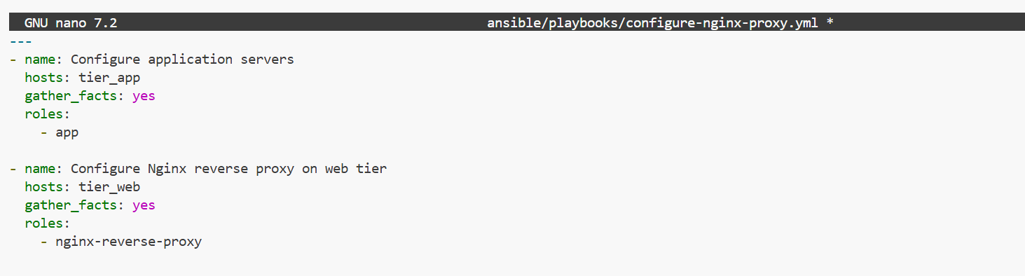
project4_part4_configure_nginx_execution.png
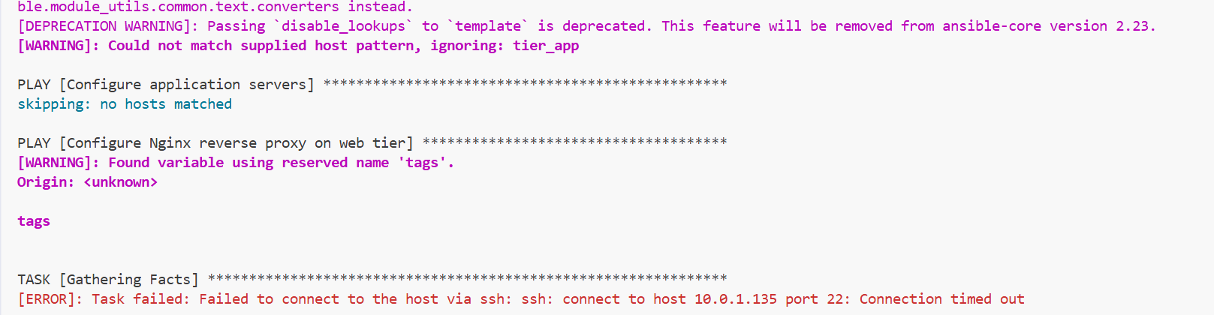

4.4 Log Collection for Evidence
project4_part4_collect_logs_playbook.png
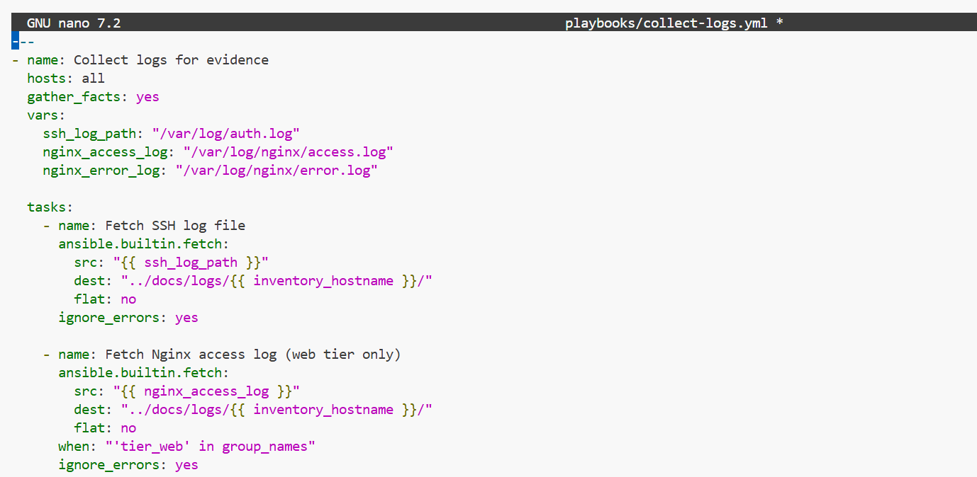
project4_part4_logs_collected_tree.png
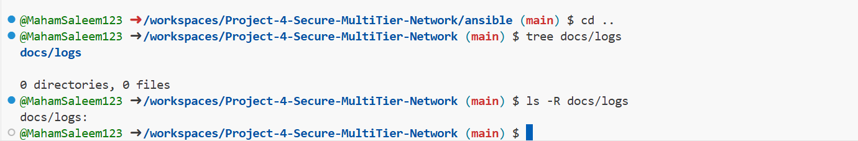

Part 5: Security Testing & Documentation
5.1 Security Architecture & Checklist
project4_part5_security_architecture_doc.png
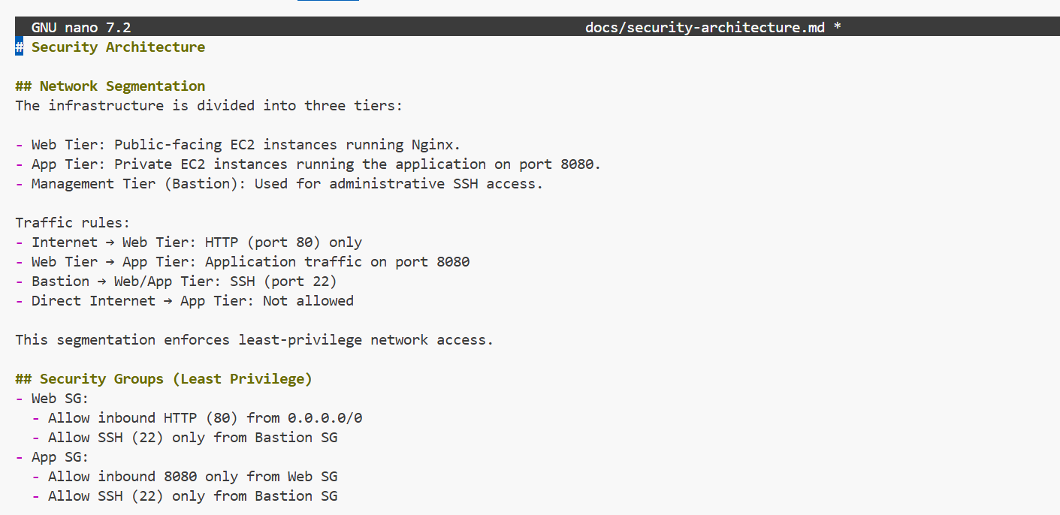
project4_part5_security_checklist_doc.png
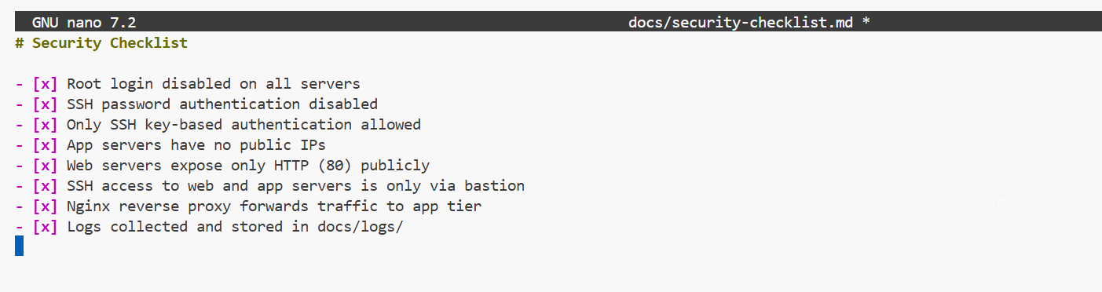
5.2 Verification & Testing
project4_part5_bastion_ssh_flow.png
SSH access to the bastion host from the public internet fails because the bastion instance is deployed in a management/private subnet that does not have a route to an Internet Gateway. Although a public IP is assigned, the subnet routing prevents inbound SSH access, enforcing network-level isolation.
project4_part5_sshd_config_evidence.png

